**User Manual(UM)**



**Team 04**

|  |  |  |
| --- | --- | --- |
| **Member** | **Role** | **Email** |
| Chengyu Shen | Project manager, operational concept developer | [**shenchen@usc.edu**](mailto:shenchen@usc.edu) |
| Shiji Zhou | Software architect, prototyper | [**shijizho@usc.edu**](mailto:shijizho@usc.edu) |
| Yufei Hong | Feasibility Analyst, project manager | [**yufeihon@usc.edu**](mailto:yufeihon@usc.edu) |
| Guanghe Cao | Software architect, life cycle planner | [caog@usc.edu](mailto:caog@usc.edu) |
| Yang Wei | Operational concept developer, prototyper | [**Wei495@usc.edu**](mailto:Wei495@usc.edu) |
| Lin Xia | Life cycle planner, feasibility analyst | [**xialin@usc.edu**](mailto:xialin@usc.edu) |
| William Goishi | IIV and V, Quality focal point | [**wgoishi@usc.edu**](mailto:wgoishi@usc.edu) |

**Version History**

|  |  |  |  |  |
| --- | --- | --- | --- | --- |
| **Date** | **Author** | **Version** | **Changes Made** | **Rationale** |
| 11/26/2017 | Yufei Hong | 1.0 | Original template for use with Yufei Hong | Initial draft with Yufei Hong |

1. **Introduction:**

This user manual describes the navigational flow of the the challenge game of the social app, Populic. In the challenge game, we have challenge system, notification system, score rank system, upcoming challenge review board, approve/decline system and also support users submit their idea for challenge tasks. The user interface of challenge game is simple, beautiful and easy to understand.

1. Challenge page home page

The home page consists of various of sections. When user click the red button below, there will be a pop up screen jump out. User can review almost all the information on the pop up screen. At the very top of the screen, it is the today’s challenge task content. Below today’s challenge’s content, user can see the number of people who sent challenge task to you on an arrow button. Also, user can send challenge to friends via challenge your friends button.

Below the challenge your friends button, user can preview upcoming challenge tasks for future 4 days. Below the upcoming challenge preview area, there is a submit button for user to submit their good challenge ideas to authority.

And finally, there is a gold rank button for user to check the score rank.

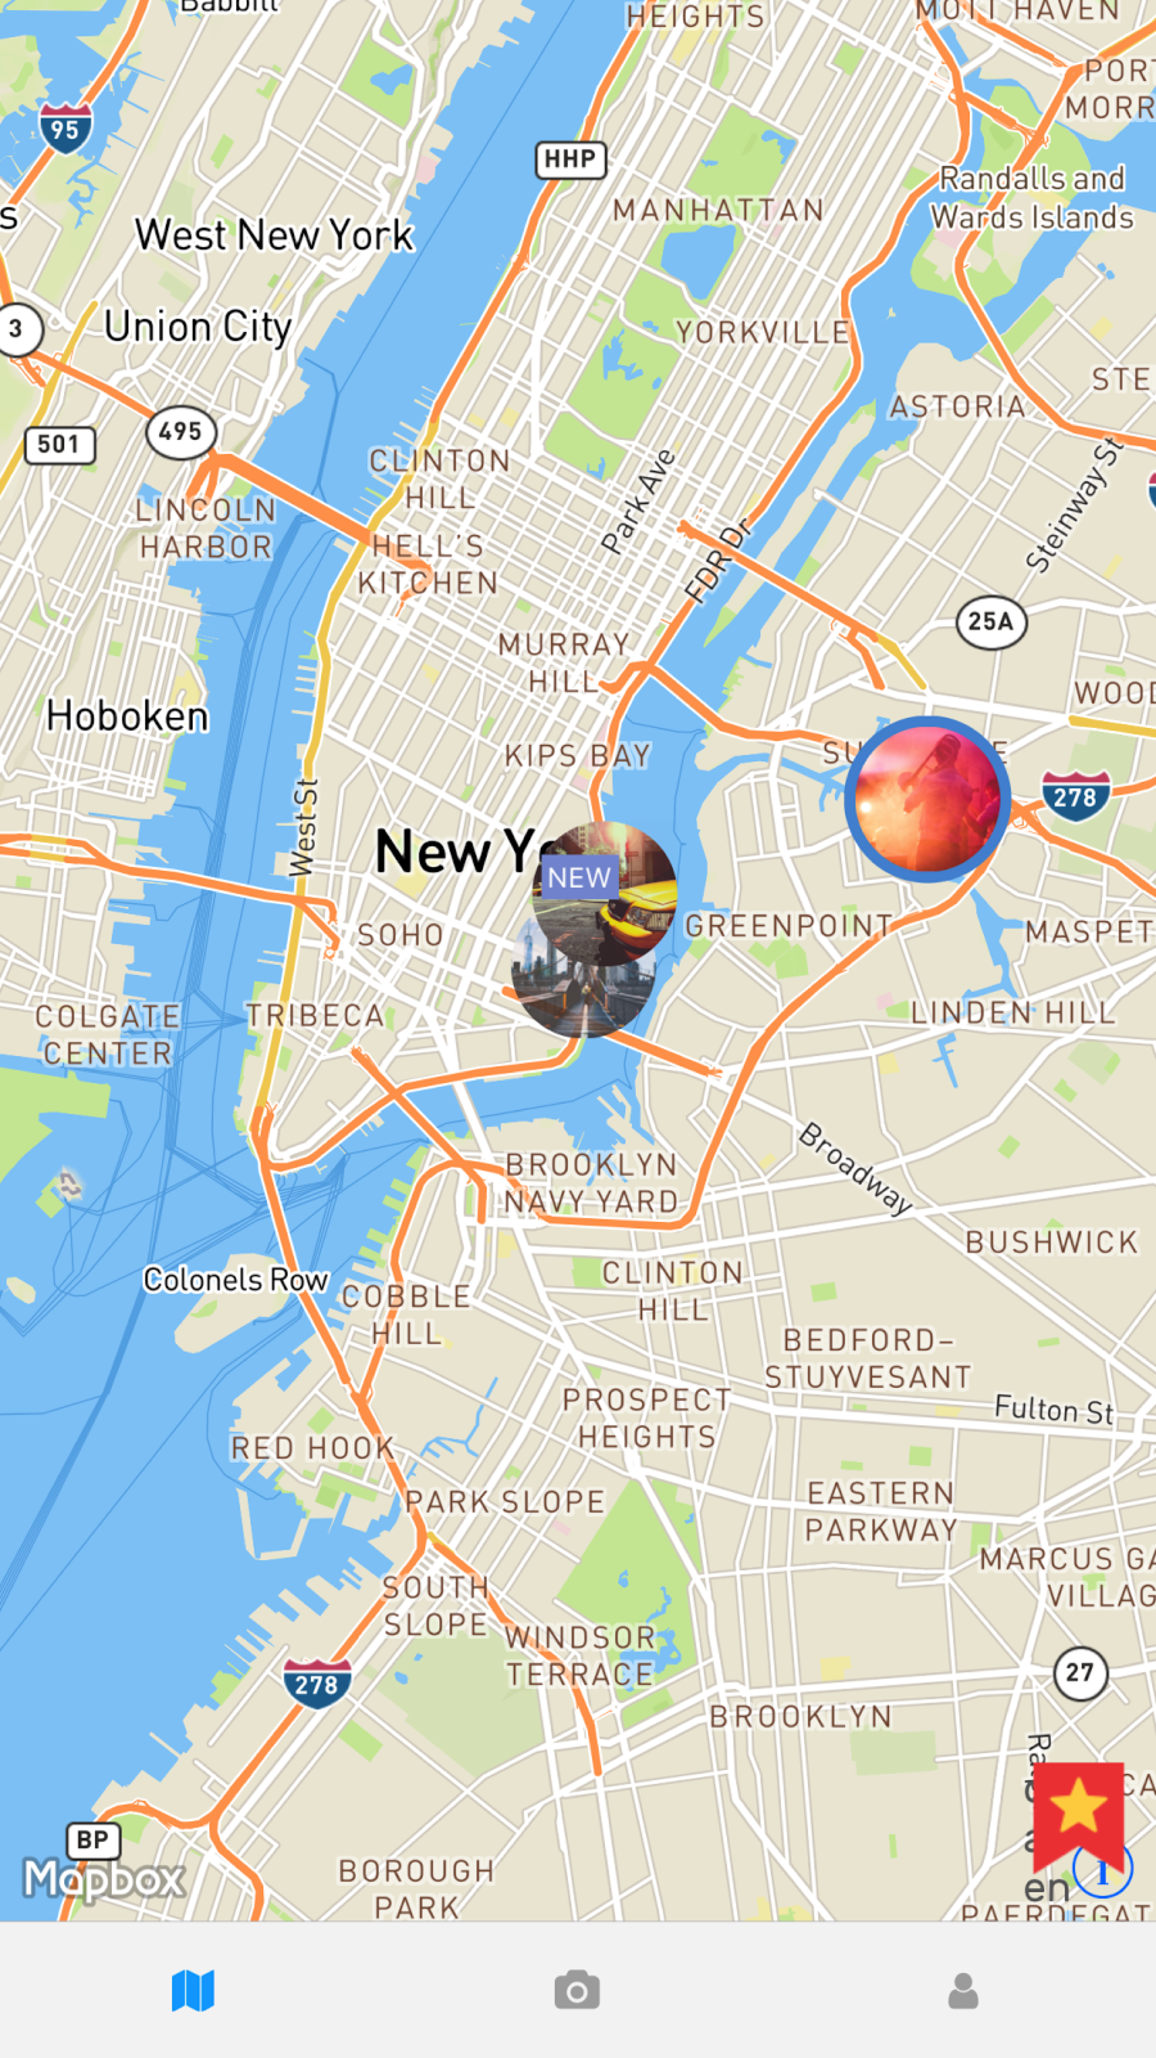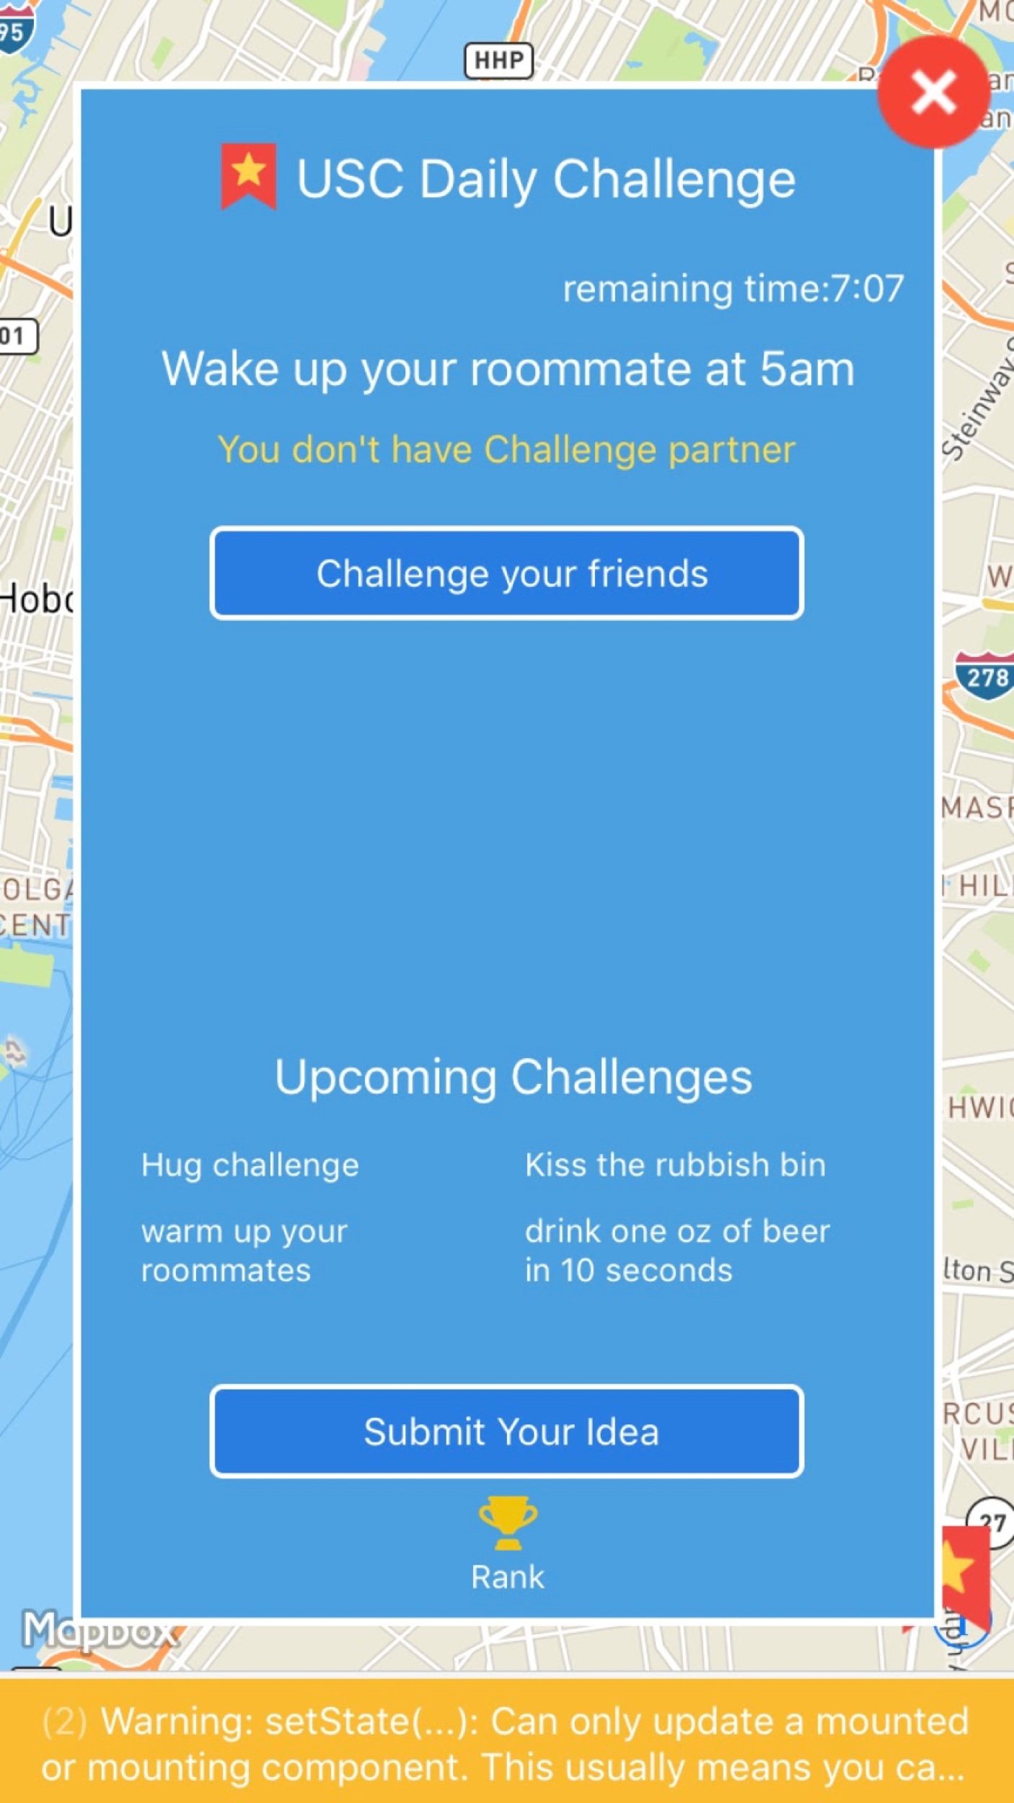

**2. Pick challengers interface**

**2.1 how to start**

When user has been challenged by friends by friends, the arrow will show the number of challengers. And also, user can view how many people he/she has challenge below challengers button.

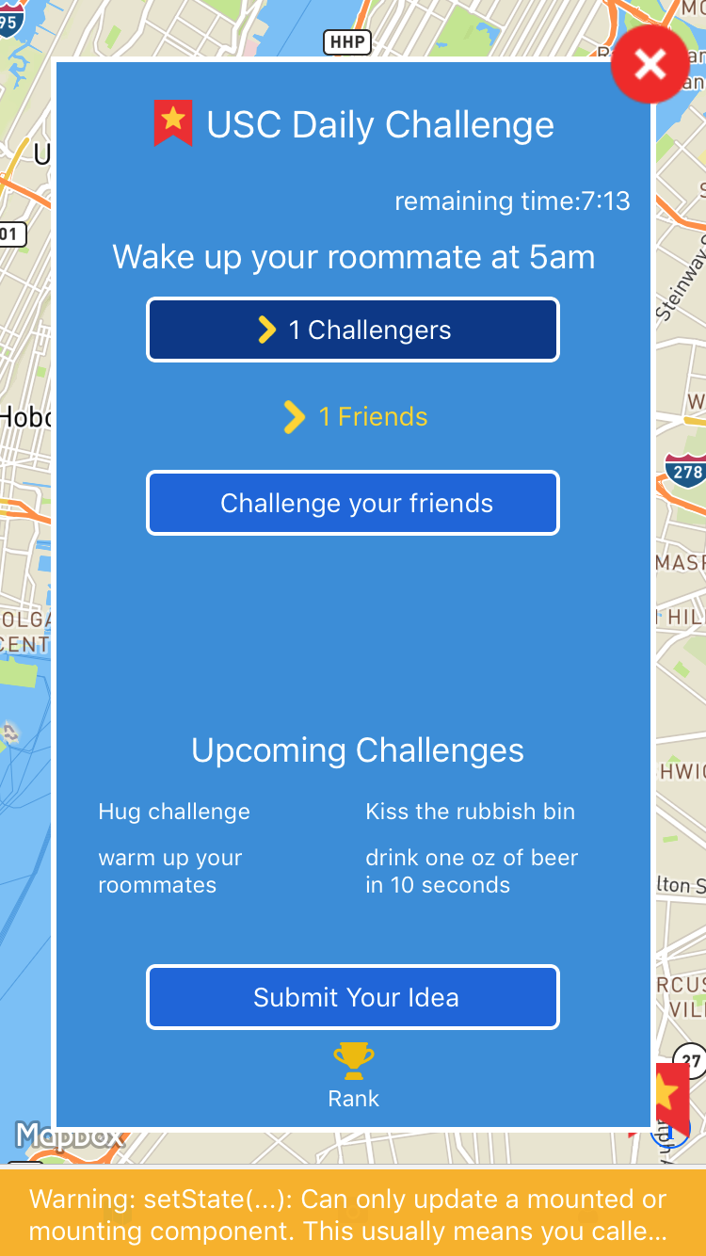

**2.2 Pick a competitor**

When user clicked arrow button, user will be navigated to competitor pick list. All the people who have challenged used user will be named on this list and user can choose one of them to start challenge game.

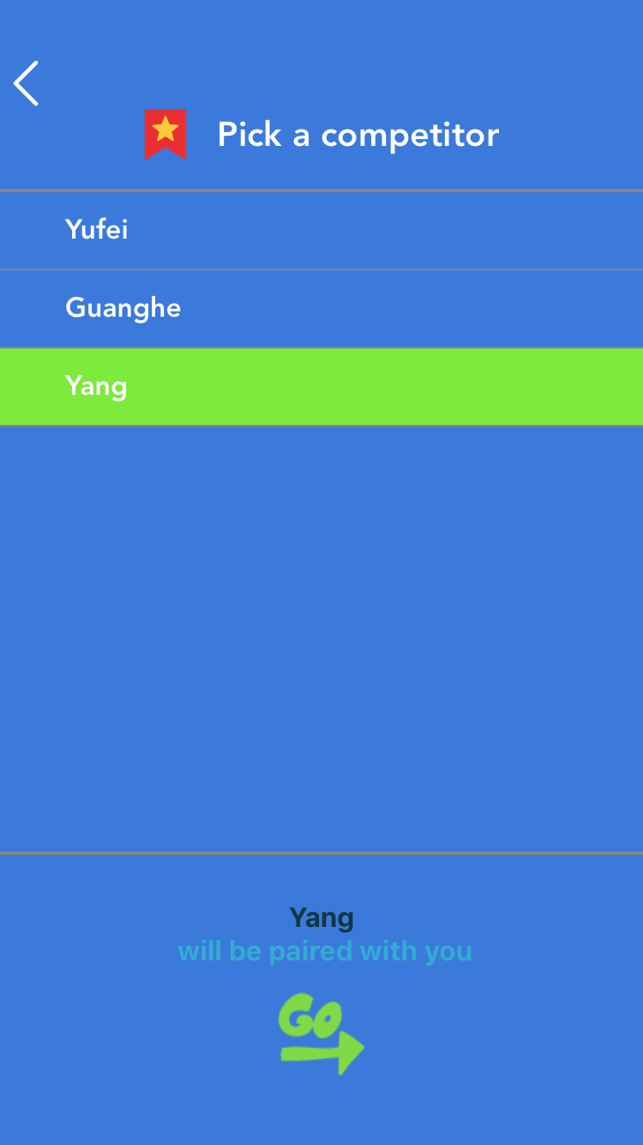

**2.2.1 Competitor has been paired by others**

When user picks a challenger but the challenger has already been picked by others, user will be noticed that to pick another challenger and the previous challenger name that was picked by user will be deleted from the list.

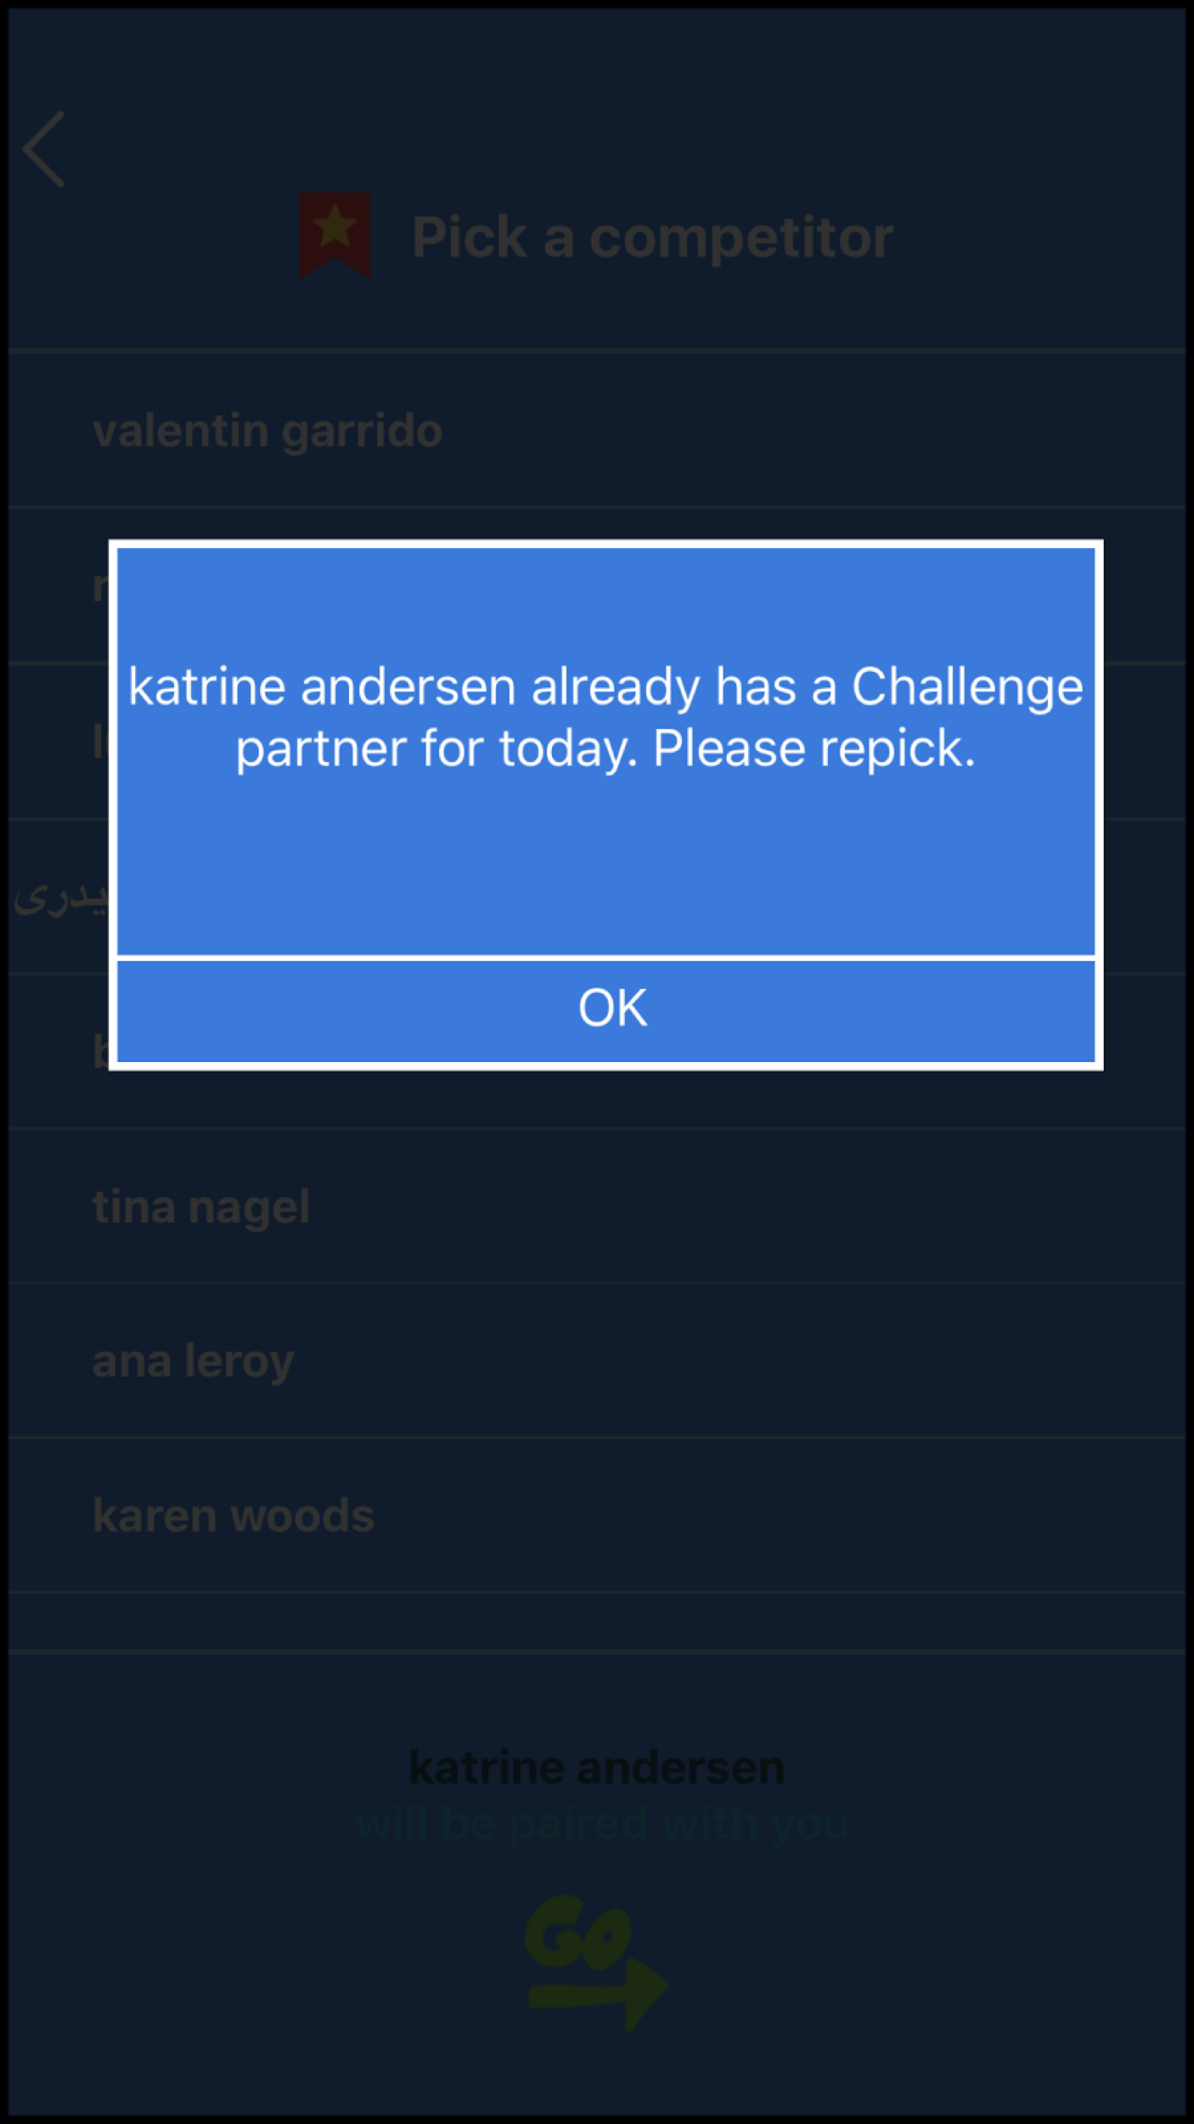

**2.3 paired success**

However, if the challenger was not paired and once user picks this challenger was not paired and once user picks this challenger, they will be paired and the challenge game will ready to start. Also, the related notification will send to competitor.

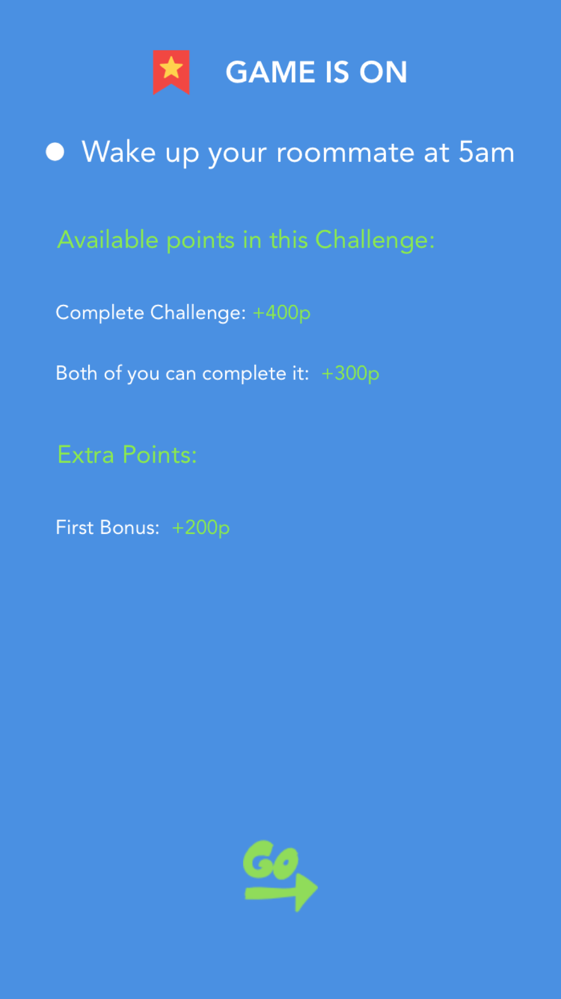

**3. Game start page**

Once user has been paired, user will be navigated to game start page. As you can see, on this page, we have today challenge content above. The right corner is the remaining time for challenge game. Below the today’s challenge content, there is a vertical that separate challenger and user into sides. User can view himself/herself and challenger’s name directly.

Below this area, there is a green do it button. Once user is ready to do the challenge, just simple click the button and user will be navigated to the camera.

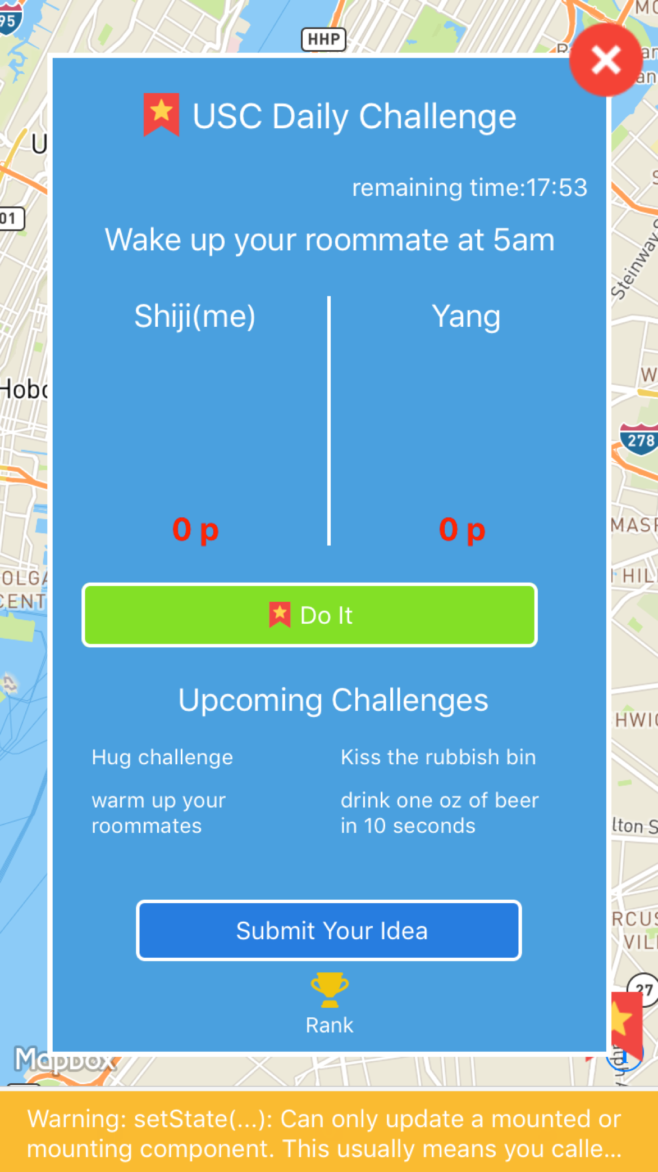

1. **Camera**

**4.1 Open camera**

When user click do it button, user will be navigated to camera and begin to do the challenge tasks.

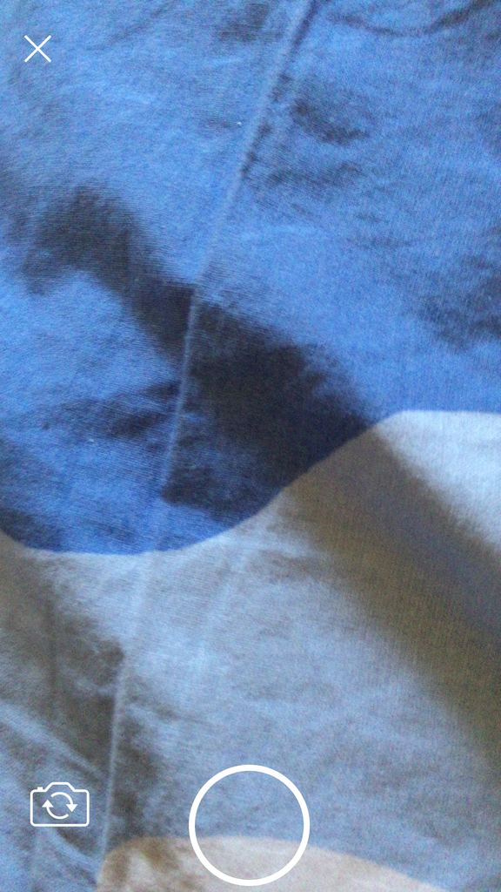

**4.2 Take a picture & send**

When user finished his/her challenge task, he/she can pick community she/he wants to post and click the right send button to send the picture. Also, user can type the text on the picture. Once the picture has been sent, related notification will also be sent to opponent.

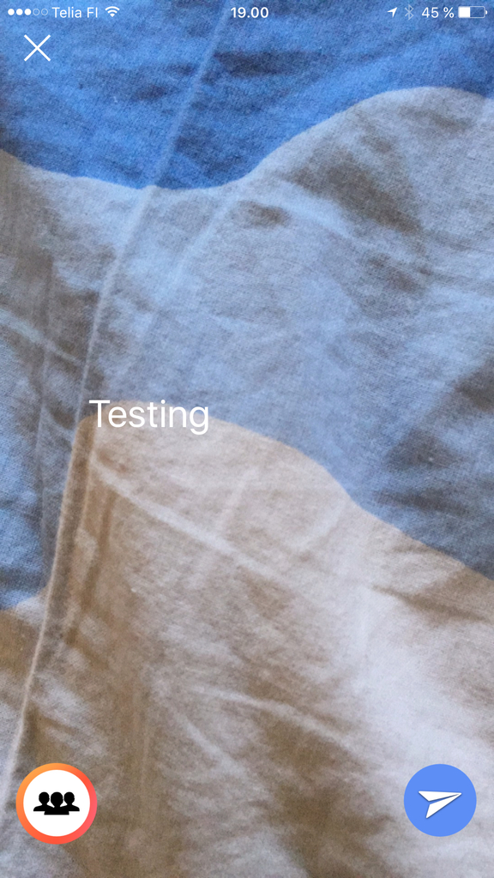

**5. Confirmation system**

When user has finished challenge task, do it button will be despaired and the finish time will be displayed below user’s name. competitor will receive a notification to confirm user’s challenge.

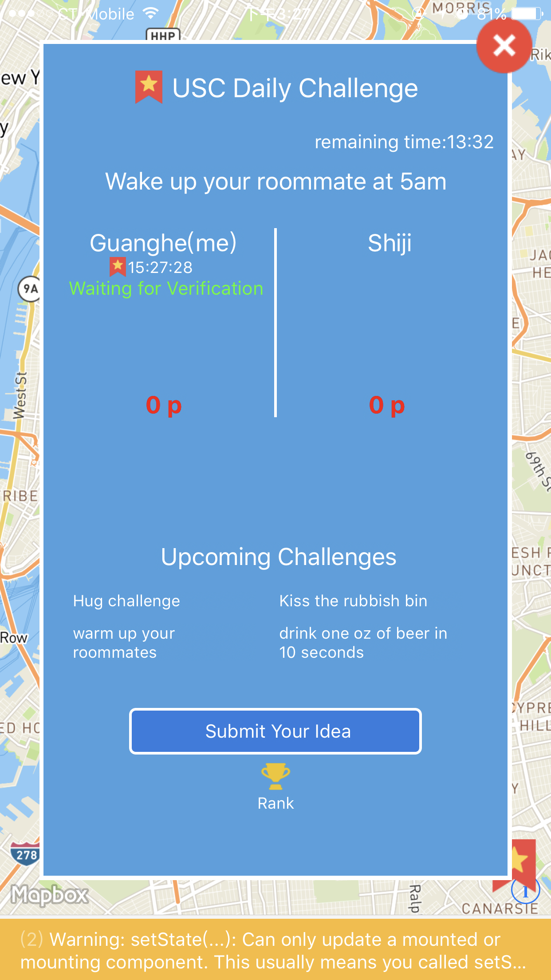

**5.1 Confirmation system**

Once competitor has finished task, user will get a notification. Both user and competitor can go to check opponent’s challenge task by simply click go to confirm.

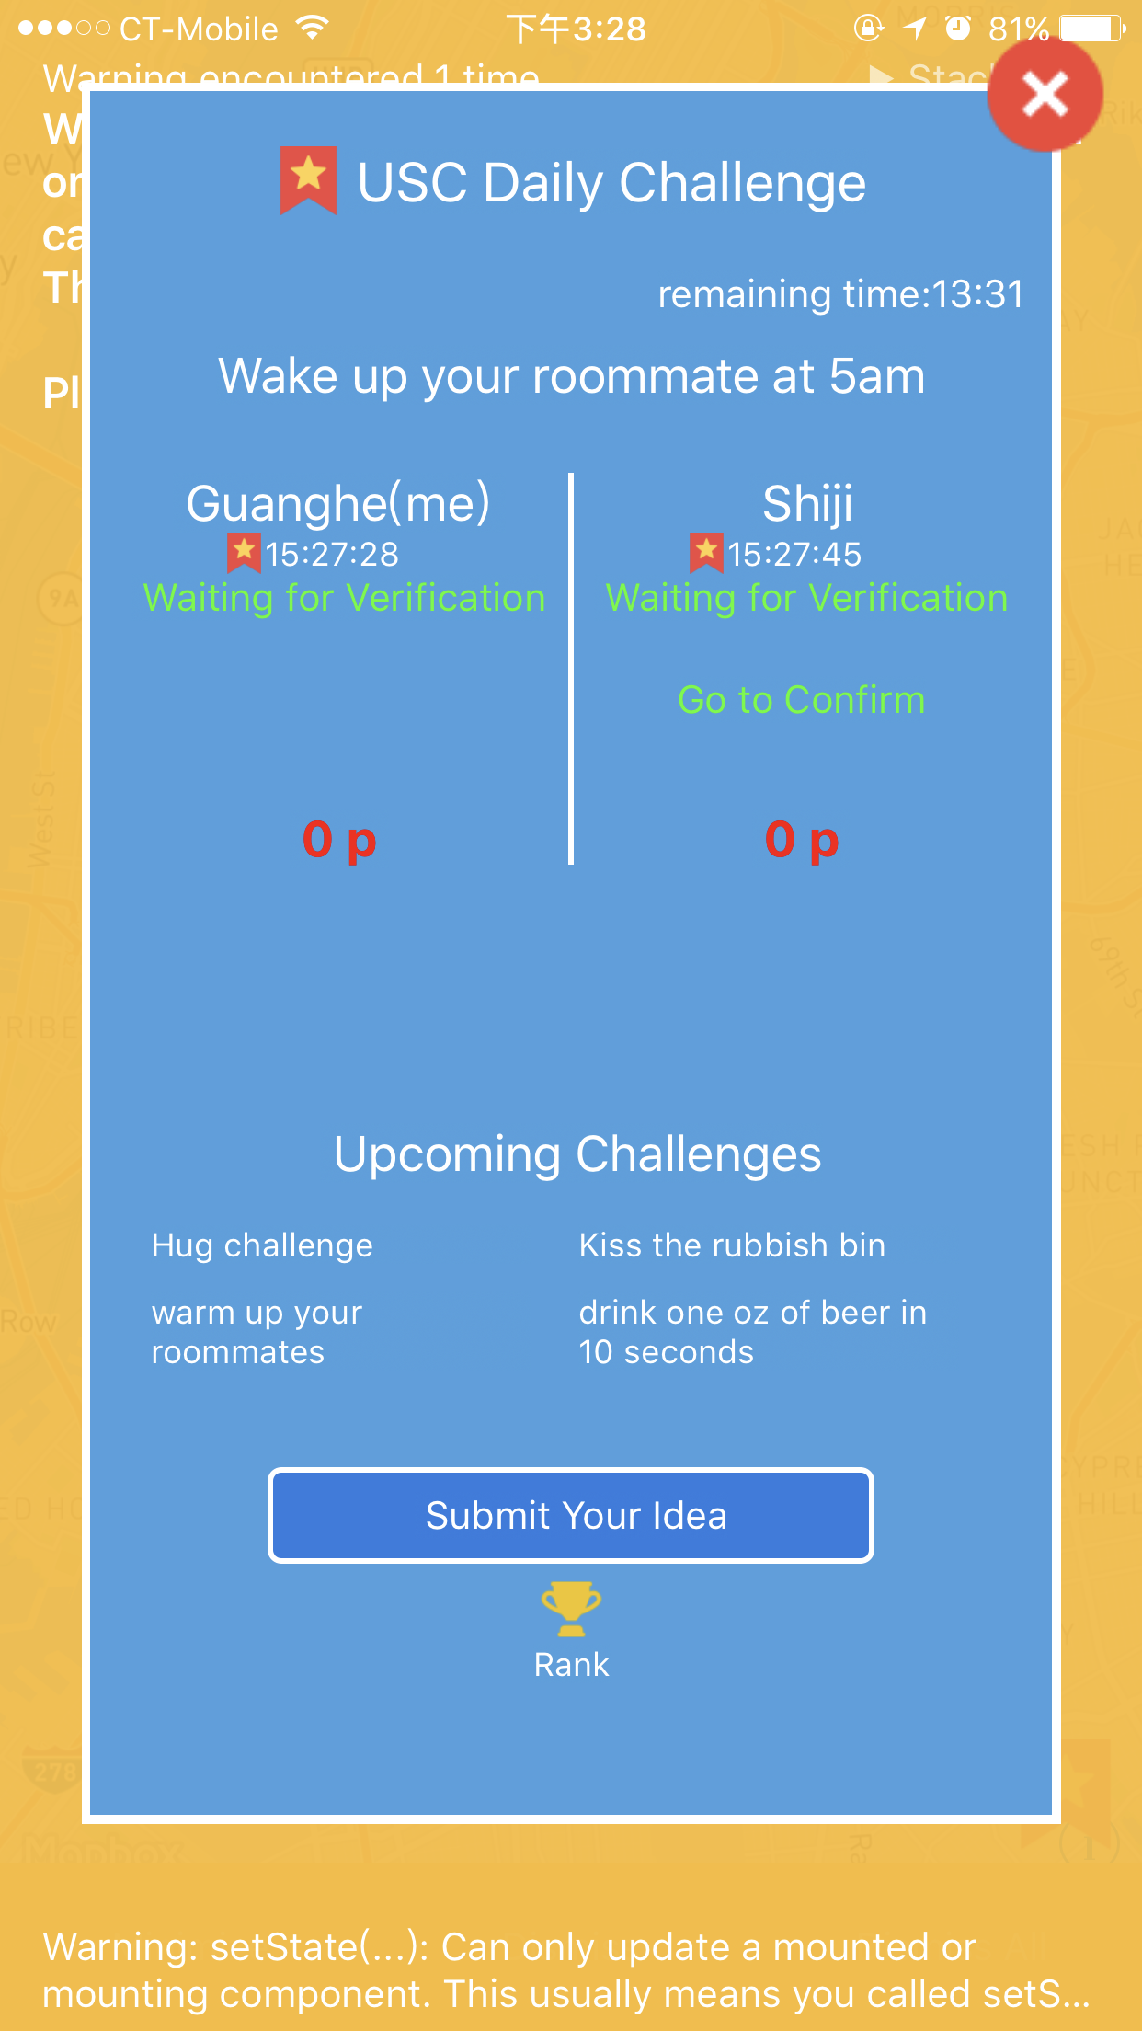

**5.2 Confirmation system**

When click verify button, user will be navigated to approve/decline page. User ca verify his/her opponent task by click approve/decline.

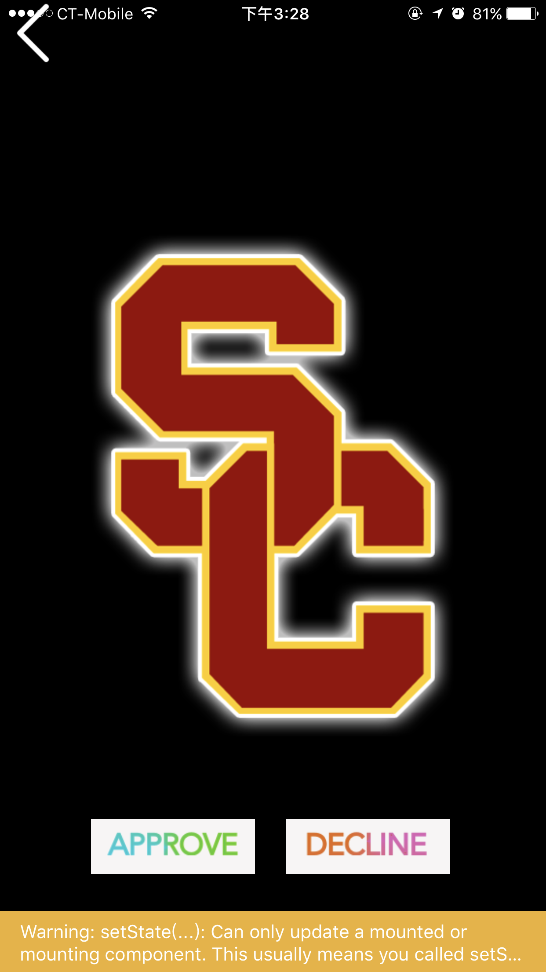

**5.3 Approve and Decline system**

When challenge task has been approved, the person who has been approved will get an approve text, approve check mark and score.

When challenge task hasa been declined, the person who has been declined will get a decline text on pop up screen and no points will be given.

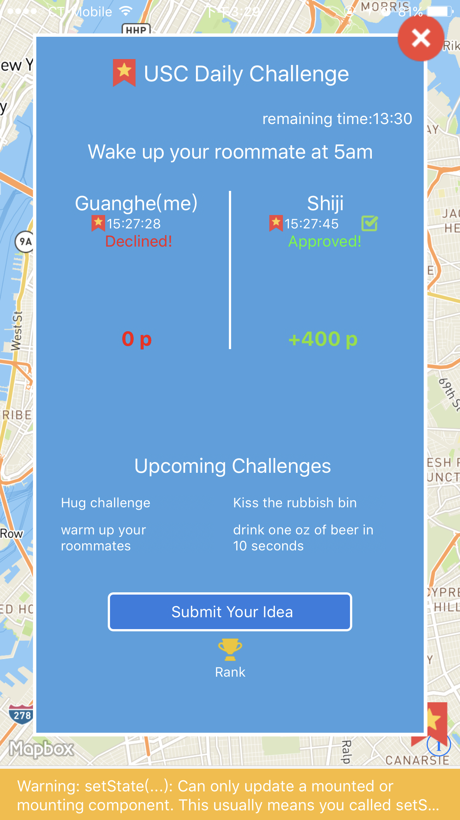

**6 Send challenge to friends**

**6.1 Challenge App friends**

When user has not been challenged, and user wants to start a challenge game, user can start it by simply click challenge your friends. After that, user will be navigated to app friend list and can pick one or more friends for challenge game. Notification will be sent to the related friends.

For example, the picture below has shown user has challenged 2 people, so, two of them will receive notification that have been challenged by user.

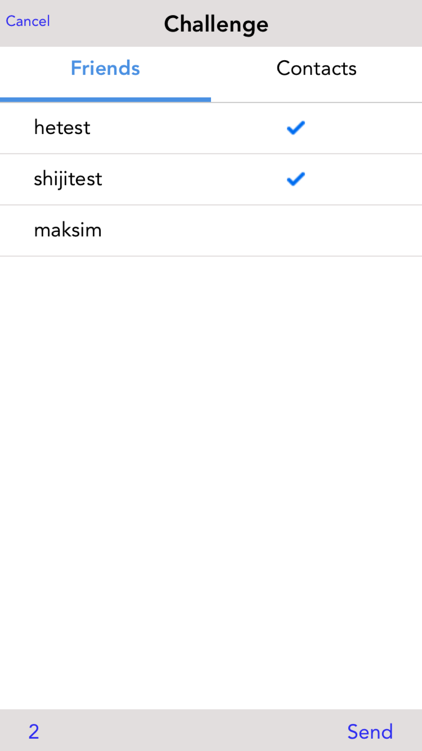

**6.2 Challenge contact list friends**

When there are no app friends online, user also can pick opponent from his/her contact list. Once user sent challenge to his/her contact list friend, his/her contact list friends will receive a text message and be asked to download our app and join the amazing challenge game.

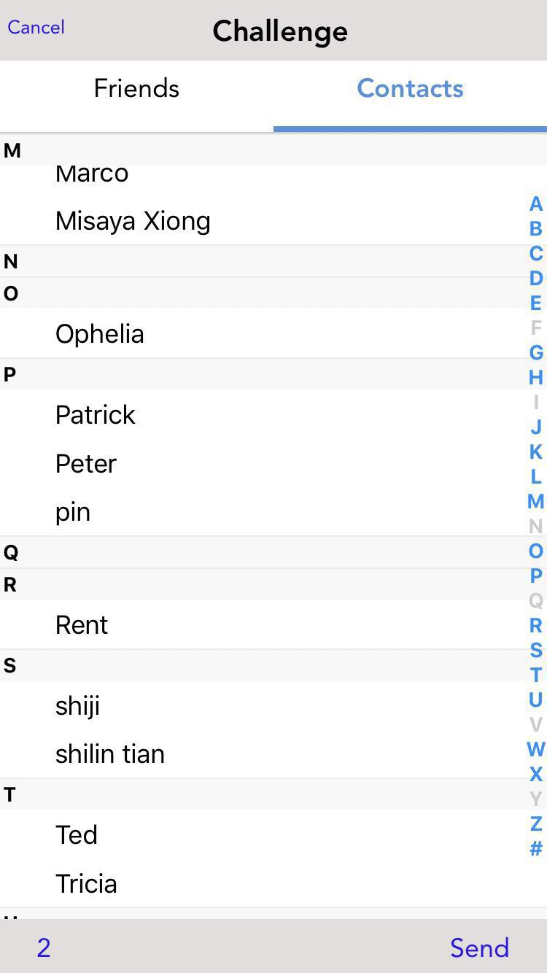

**7 Send challenge to friends**

User can view the score system via the score rank list by simply click the trophy cup button.

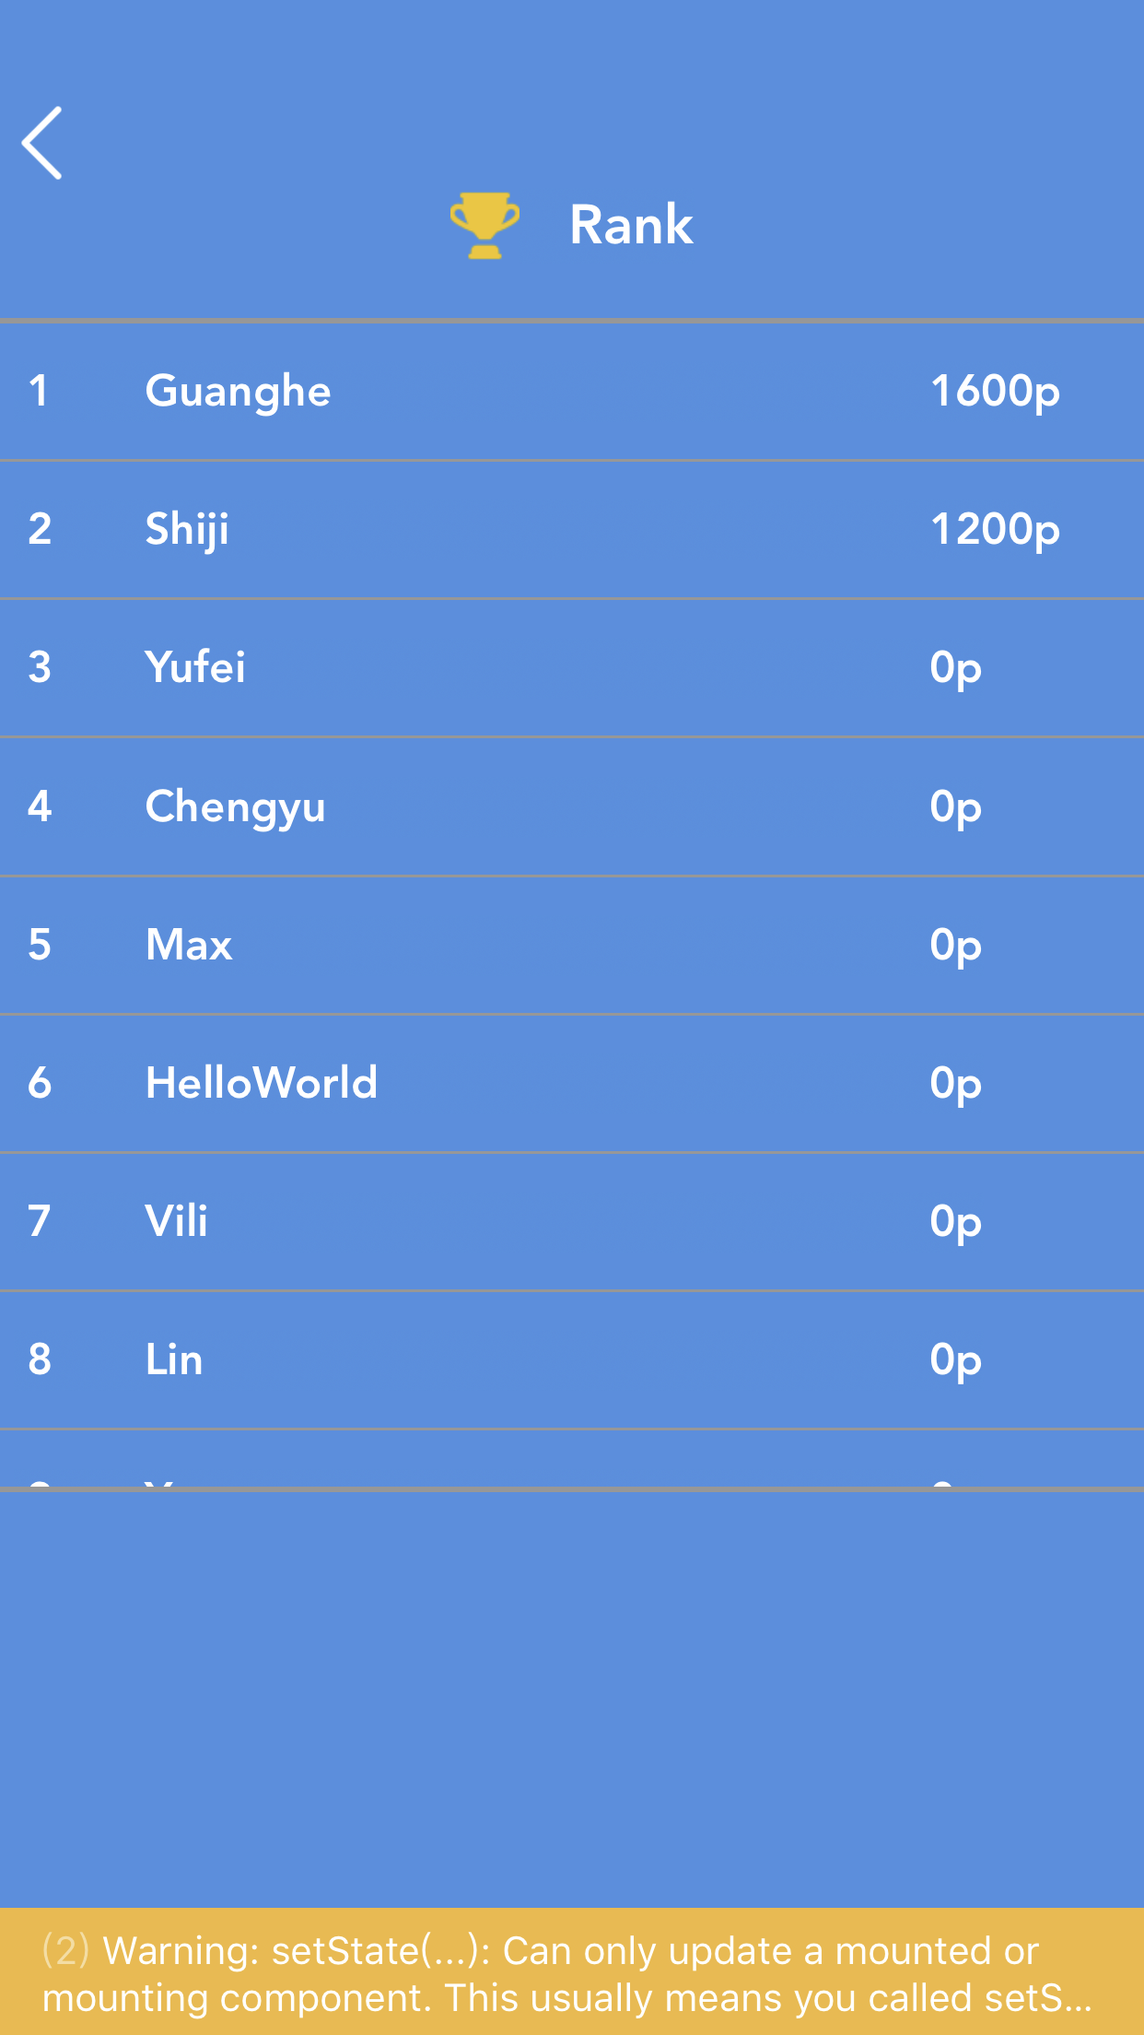

**8 User challenge idea submission**

User can submit any interesting challenge idea to authority and make the challenge game more interesting.

